New Delhi, India

October 23, 2024



Data Manager GUIDE

*Vegetable Irrigation for Climate Resilience Toolkit (VICT) Platform*

**Table of Contents**

1.0 INTRODUCTION 4

2.0 LOGIN 6

3.0 DATA SUMMARY 7

4.0 DATA 9

4.1 DATA ENTRY 9

Add 10

4.2 DATA APPROVE 11

4.3 DRIVER DATA ENTRY 12

Add 12

4.4 INDICATOR METADATA 14

Import 14

Add 15

4.5 IMPORT DATA 17

4.6 DOWNLOAD DATA 20

5.0 CONTENT 21

5.1 CATEGORY SUBCATEGORY 21

Add 22

5.2 DOCUMENTS 23

Add 24

6.0 ADMIN 26

6.1 AREA 26

Import 26

Add 27

6.2 TIME PERIOD 29

6.3 DATA SOURCE 30

6.4 INDICATOR 33

Import 33

6.5 IMPORT MAPPING 35

6.6 CLASSIFICATION 37

1.1.2 Classification Type 38

1.1.3 Classification 40

6.7 USER 43

6.8 LANGUAGE 45

1. **INTRODUCTION**

This user manual is developed to help data administrators understand the use of the Data Manager application and its modules. This application will only be accessed to the users with valid login credentials.

The Data Manager application comprises various data management modules. These modules allow the creation and management of the data and their elements.

**NOTE:** Valid login credentials are required to access the Data Manager application.

The Data Manager application contains the following modules and submodules -

* Data Summary
* Data
  + Data Entry
  + Data Approve
  + Driver Data Entry
  + Indicator Metadata
  + Import Data
  + Import Log
  + Download Data
* Content
  + Category - Subcategory
  + Documents
* Admin
  + Area
  + Time Period
  + Data Source
  + Indicator
  + Import Mapping
  + Classification
* Classification Type
* Classification
  + User
  + Language

Each of these modules is explained in detail in the following chapters

1. **LOGIN**

The Data Manager application can be accessed through a web browser. While the application is cross-browser compatible, Google Chrome's latest version is the recommended browser for a better experience. Enter the following URL <https://vict.itechmission.org/datamanager/> in the web browser. You will land on the login page of the data manager application. In the login panel enter the email and password with a valid captcha. Click on the Login button to validate (see below figure). 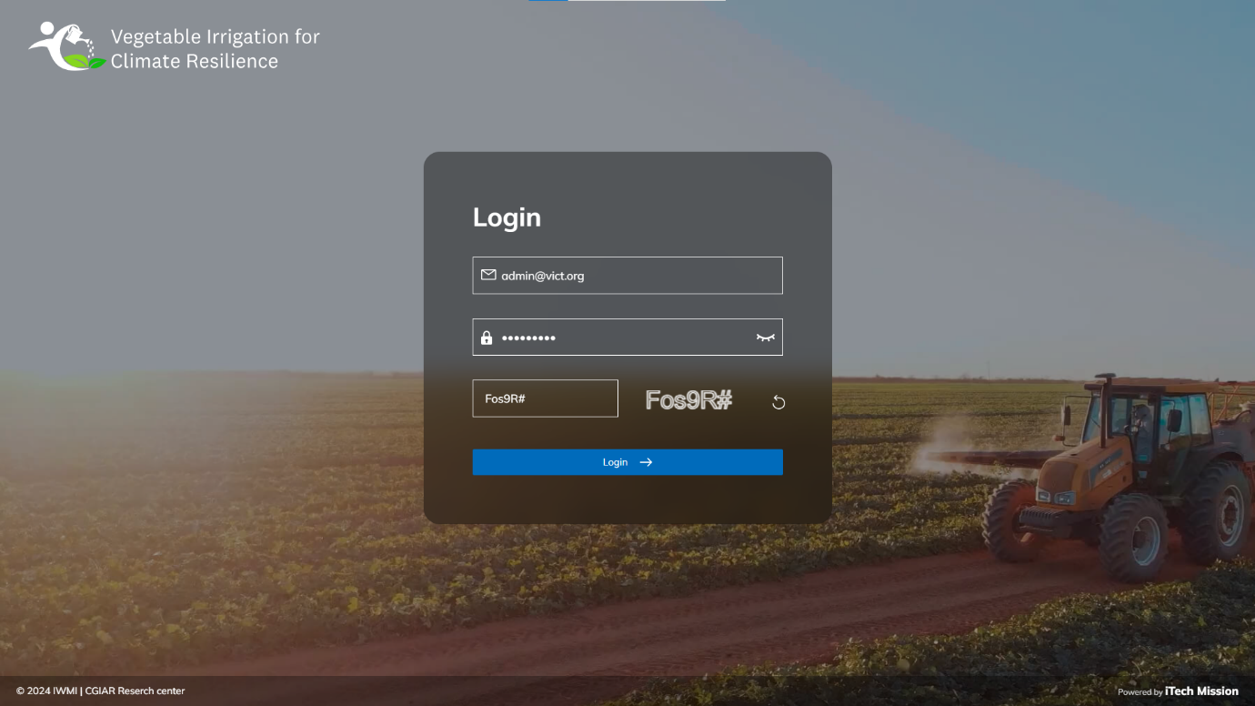

1. **DATA SUMMARY**

The first module after successful login is **Data** **Summary**. You can also access this module by clicking on the Data Summary option in the left panel (see below figure). 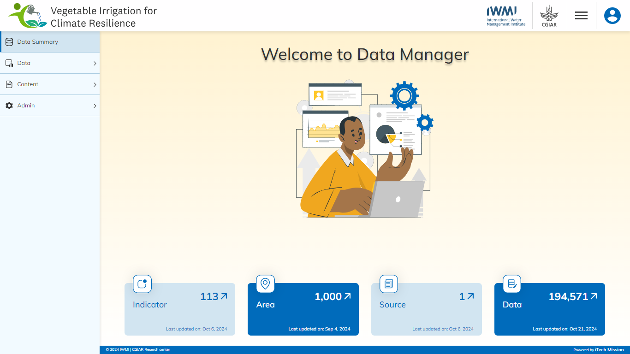

This module depicts the following information from the database.

1. **Indicator**

The first box shows the total count of indicators available in the database and the last date/time when the indicator list was entered/updated. There is an arrow button available to navigate to the respective module.

1. **Area**

The second box shows the total count of areas available in the database, along with the most recent date/time when the area list was entered or updated. An arrow button is provided for navigation to the respective module

1. **Source**

The third box shows the total count of sources available in the database, along with the most recent date/time when the source list was entered or updated. An arrow button is provided for navigation to the respective module.

1. **Data**

The fourth and last box shows the total count of data values entered against the unique combination of Indicator – Unit – Subgroup, Area, Time Period and Source along with the last date/time when the data value was entered/updated. There is an arrow button available to navigate to the respective module.

1. **DATA**

Click on the **Data** menu option from the left panel to access this module. This module has seven submodules – **Data Entry, Data Approve, Driver Data Entry, Indicator Metadata, Import Data, Import Log,** and **Download Data**.

Let us understand these submodules in detail.

* 1. DATA ENTRY

Click on the **Data Entry** from the Data menu option from the left panel to access this module. This module allows to manage the Data master list. You will have options to add a new element, view the list of existing elements, sort the list, search from the list, edit and delete the existing elements (see below figure). 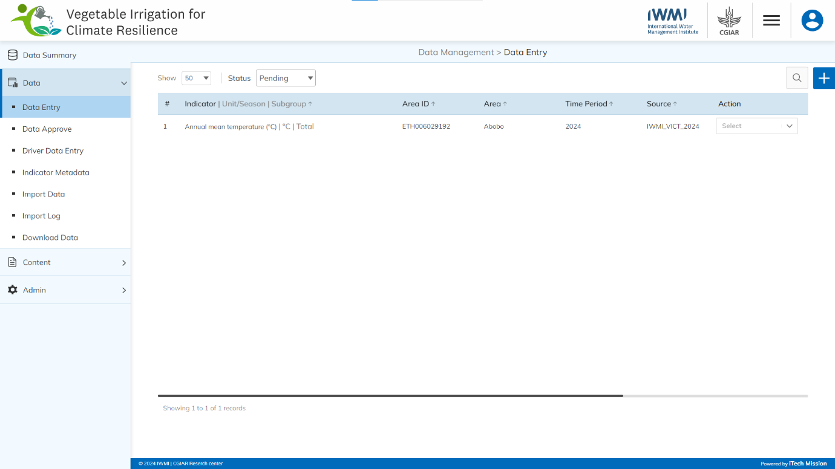

### Add

Click on the **Plus** button available at the top right corner to add a new data record.

Enter the following details to add a new record.

* Select **Indicator |Unit/Season**
* Select **Subgroup**
* Select **Area**
* Select **Time Period**
* Select **Source**
* Enter **Data Value**
* 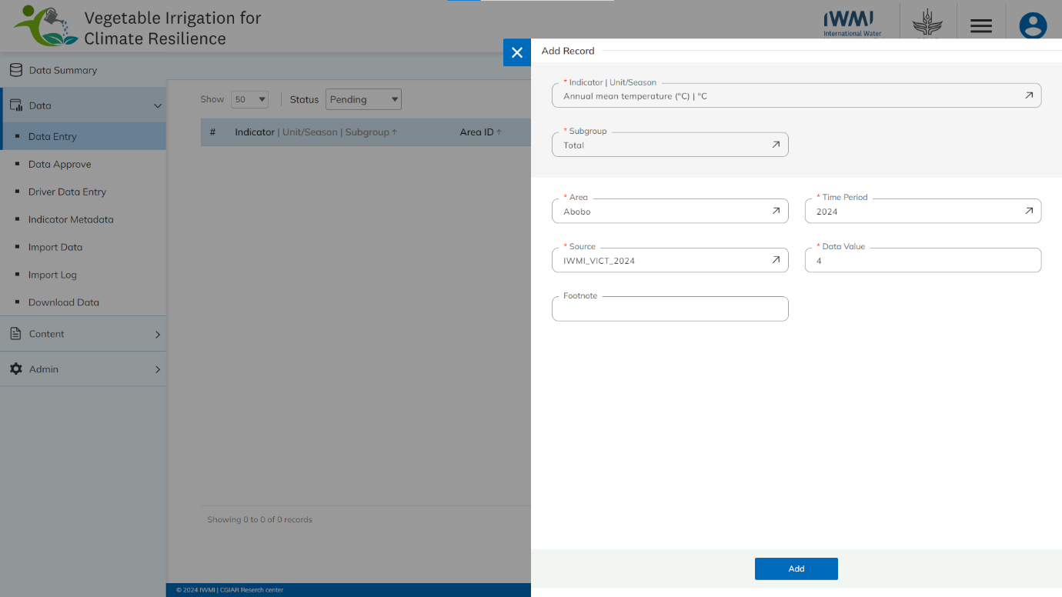Enter **Footnote**

All blue color details are mandatory to be entered. Click on the **Add** button to save and confirm. You can now view the new record added in the list.

Click on the **Edit** option available in the action dropdown to edit the details of the selected element. Edit the required detail and click on the update button to save and confirm.

Click onthe **Delete** option available in the action dropdown to delete the selected element. A confirmation popup will appear, click yes to confirm the deletion.

* 1. DATA APPROVE

Click on the **Data Approve** option from Data menu option from the left panel to access this module This module allows to manage approval of the added/updated data records. You will have the option to approve the pending data that has been added or updated using the Data entry module (see below figure). 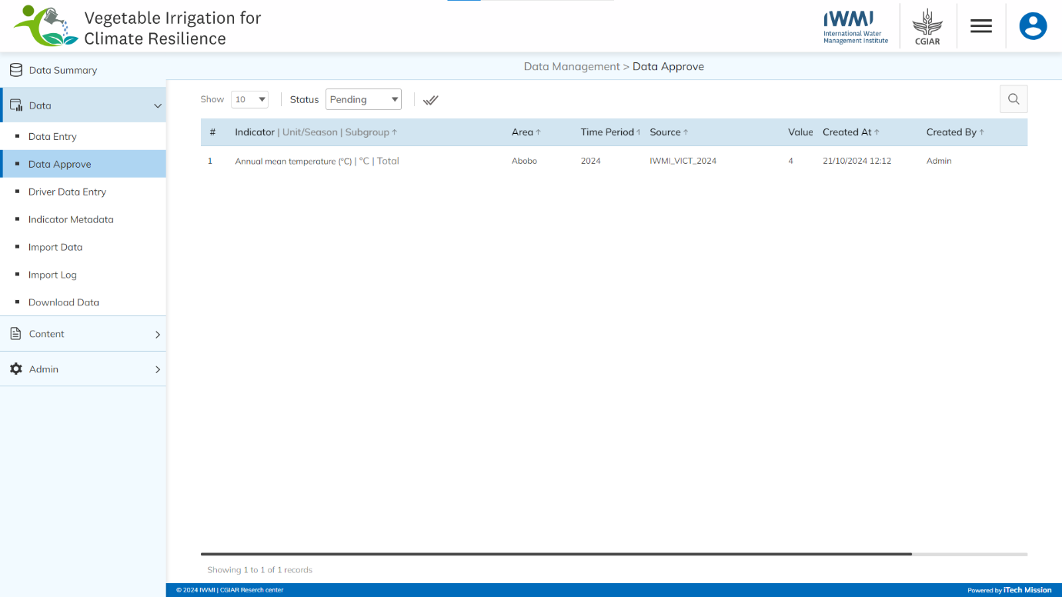

To approve a pending record, click on the **Approve** option available for each pending data record in the action column. The data record will be moved to the approved list and it can now be viewed on the user interface application.

****To disapprove a pending record, click on the **Disapprove** option available for each pending data record in the action column. You will be asked to confirm the disapproval and you can also add remarks for disapproval. To approve all data records at once, click on the **Approve All** button available at the top left corner of the page.

* 1. DRIVER DATA ENTRY

Click on the **Driver** **Data Entry** from the Data menu option from the left panel to access this module. This module allows to manage the driver master list. You will have options to add a new element, view the list of existing elements, sort the list, search from the list, edit and delete the existing elements (see below figure). 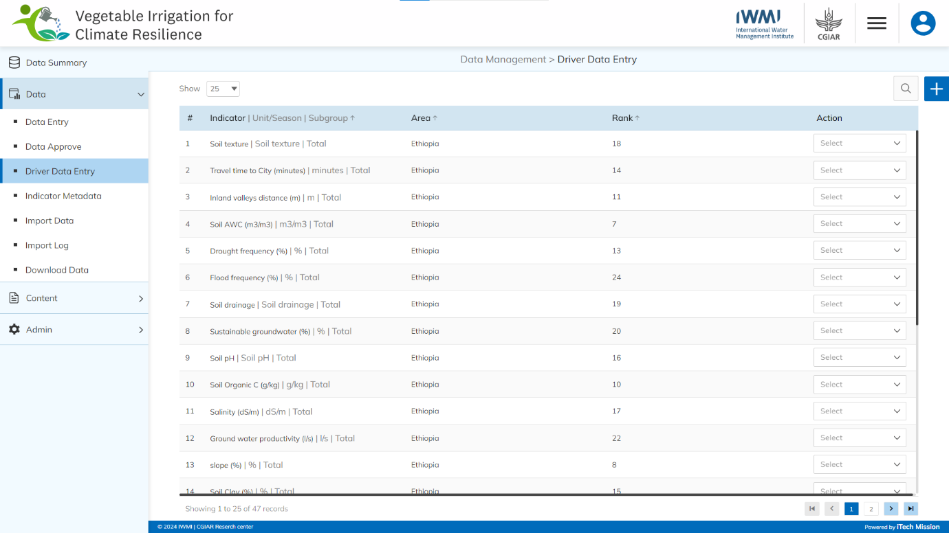

### Add

Click on the **Plus** button available at the top right corner to add a new record.

Enter the following details to add a new record.

* Select **Area**
* Select **Indicator |Unit/Season**
* Enter **Rank**
* Upload Map Image
* Upload Legend Image

All blue color details are mandatory to be entered. Click on the **Add** button to save and confirm. You can now view the new record added in the list.

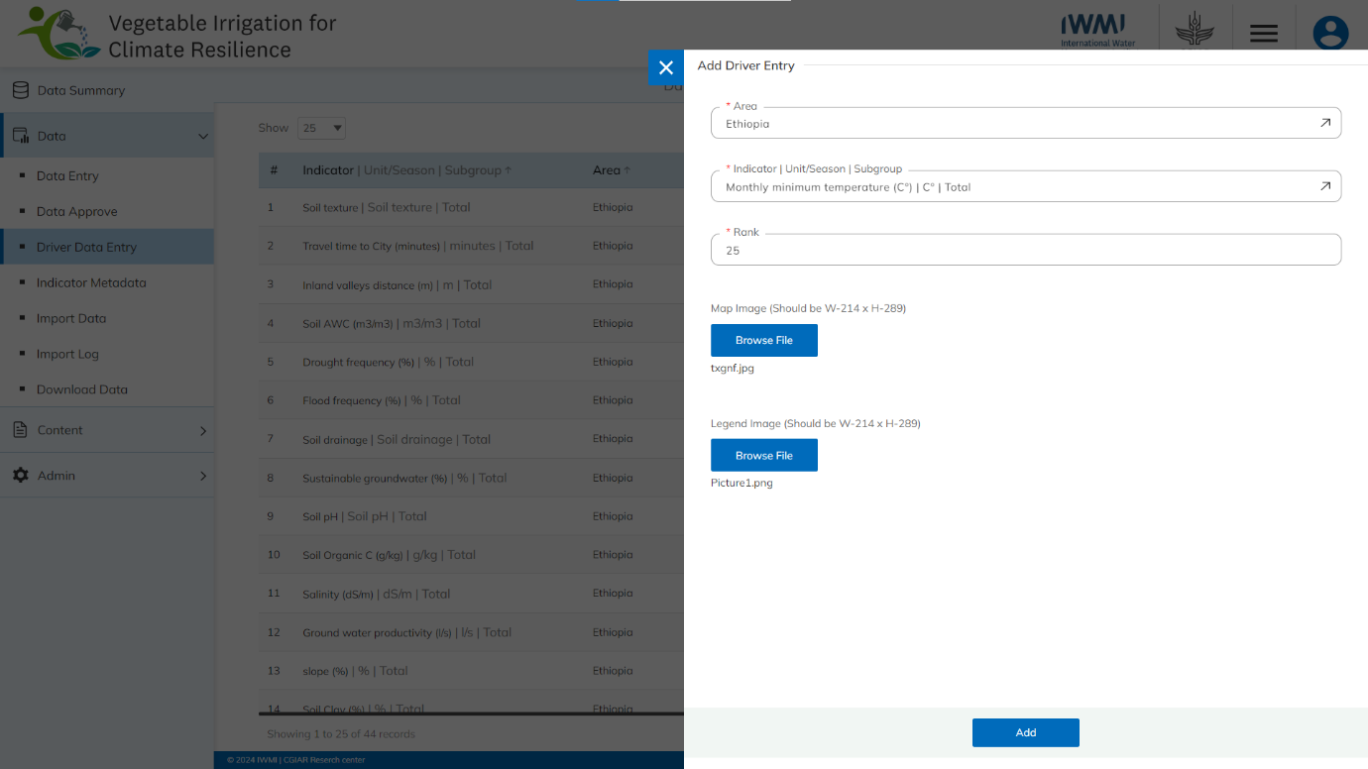Click on the **Edit** option available in the action dropdown to edit the details of the selected element. Edit the required detail and click on the update button to save and confirm.

Click on the **Delete** option available in the action dropdown to delete the selected element. A confirmation popup will appear, click yes to confirm the deletion.

* 1. INDICATOR METADATA

Click on **Indicator Metadata** from the Data menuoption available in the left panel to access this module. This module allows to manage the master data of indicators’ metadata. You will have options to import data templates, add a new element, view the list of existing data, edit, disable, and delete the existing data (see figure below). 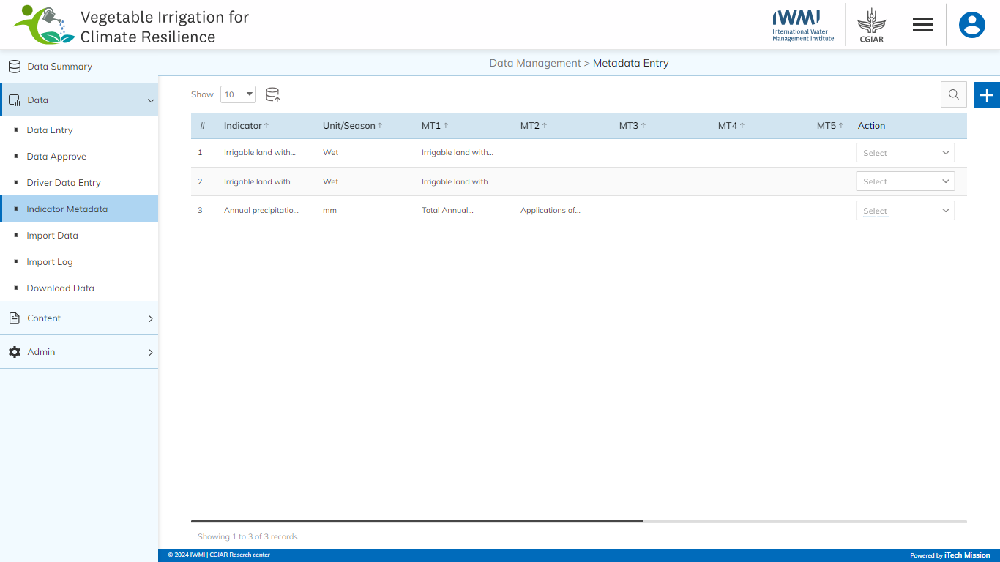

### Import

Click on the **Import** button to browse the file and upload the data master list into the database (see below figure). 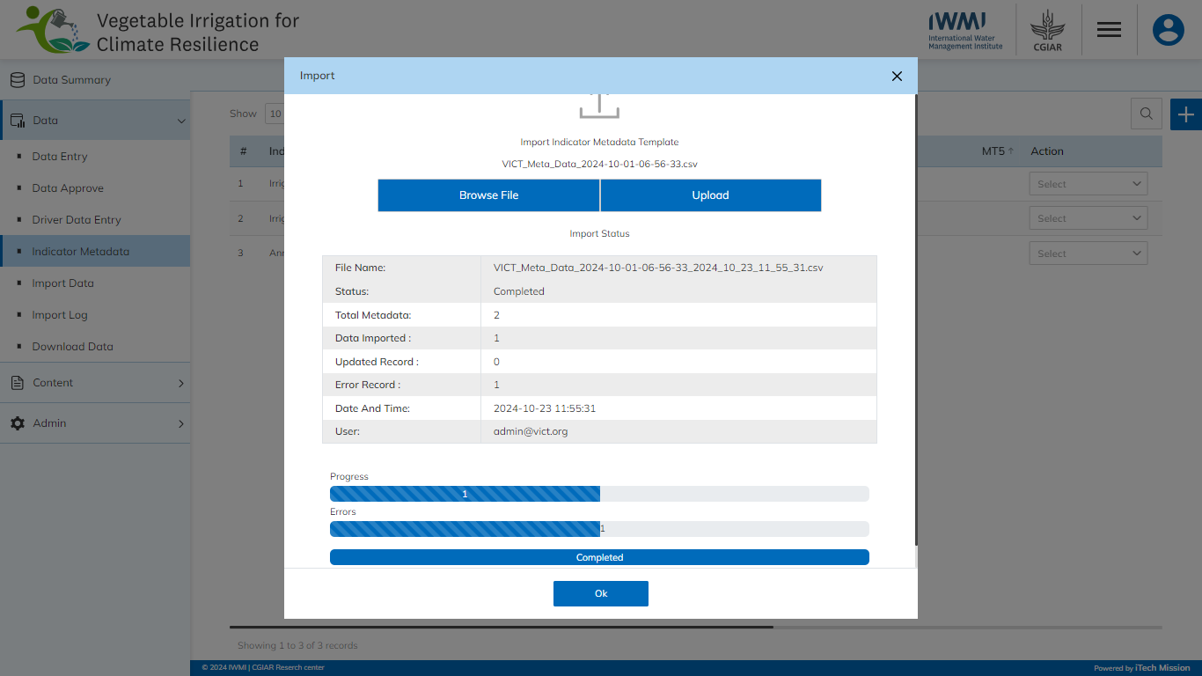

To upload the data into the database first enter the data structure in the template and then click on the **Browse File** button to select the template. Now, click on the **Upload** button to start the import process. During the import process, the records which contain blank entries, entries with special characters, and duplicate entries are not imported into the database.

A Last Upload summary will appear after the import process which provides the count of successfully imported records out of the total records. An error log will be generated to report on unsuccessfully imported records which you can access from the **Import** **Log** module.

### Add

Click on the **Plus** button available at the top right corner to add a new indicator metadata record. Enter the following details to add a new record.

* Select **Indicator |Unit/Season**
* Enter **MT1**
* Enter **MT2**
* Enter **MT3**
* Enter **MT4**
* Enter **MT5**
* Enter **MT6**
* Enter **MT7**
* Enter **MT8**
* Enter **MT9**

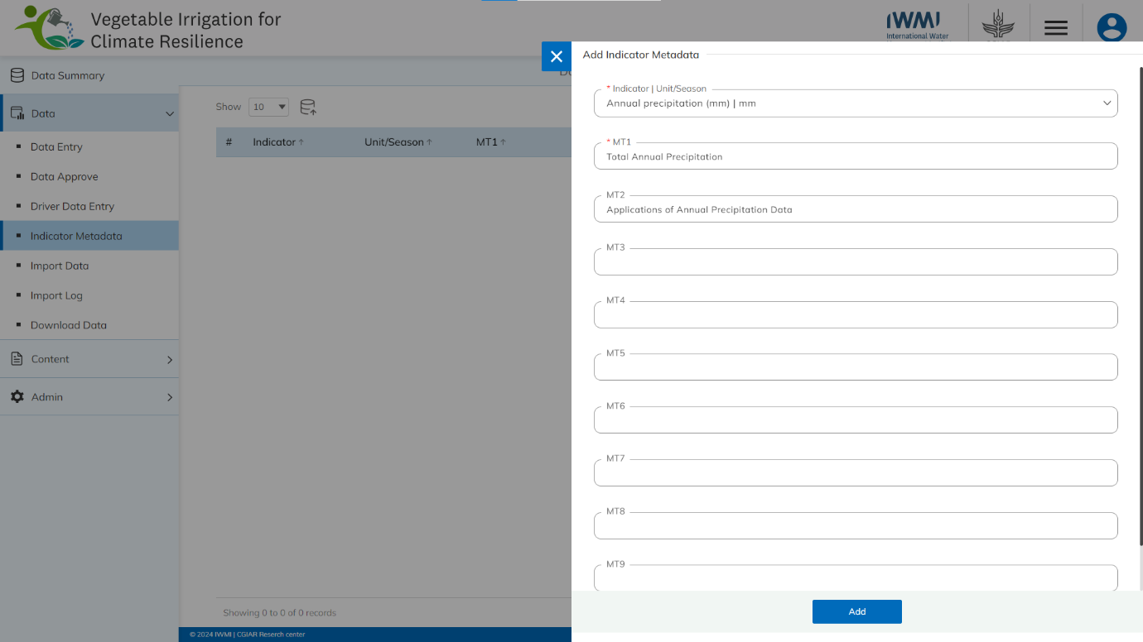All blue color details are mandatory to be entered. Click on the **Add** button to save and confirm. You can now view the new record added in the list.

Click on the **Edit** option available in the action dropdown to edit the details of the selected element. Edit the required detail and click on the update button to save and confirm.

Click on the **Enable/Disable** option available in the action dropdown to show or hide the specific indicator. The hidden indicator will not be shown in the list of indicators throughout the application.

Click on the **Delete** option available in the action dropdown to delete the selected element. A confirmation popup will appear, click yes to confirm the deletion.

* 1. IMPORT DATA

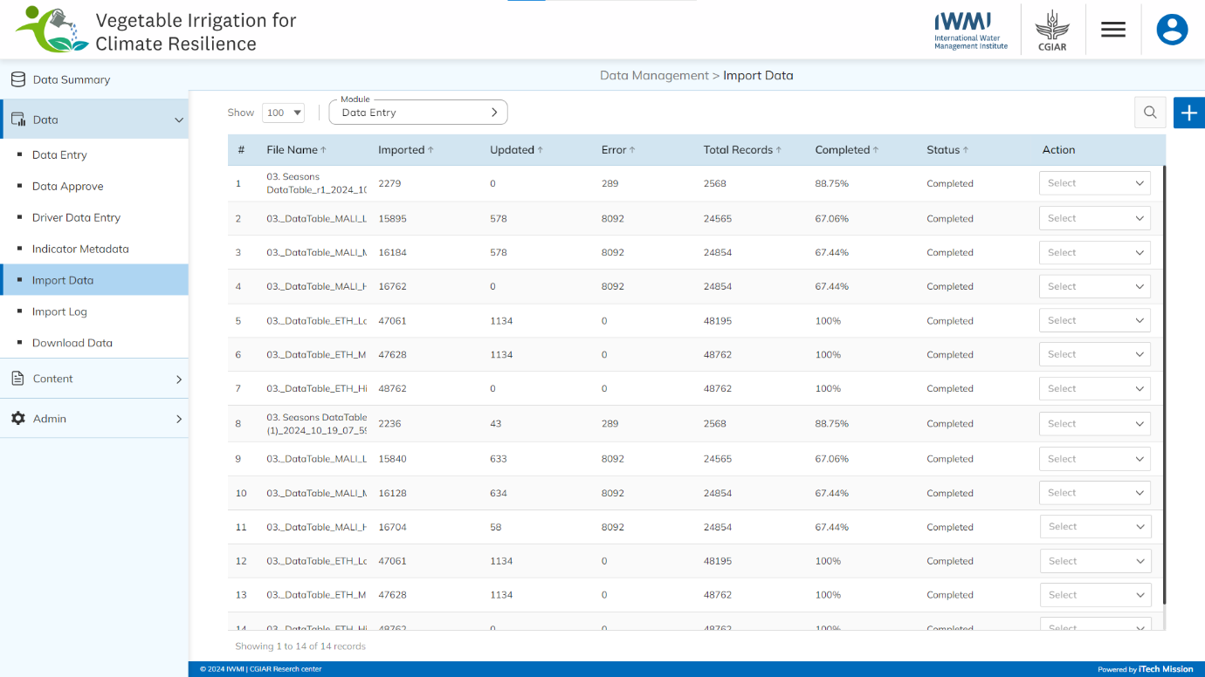Click on the **Import Data** from Data menu option from the left panel to access this module. This module allows to manage the bulk data entry processes. You will have options to view the list of existing elements of the selected module, sort the list, search from the list, download log, and delete the existing elements (see below figure).

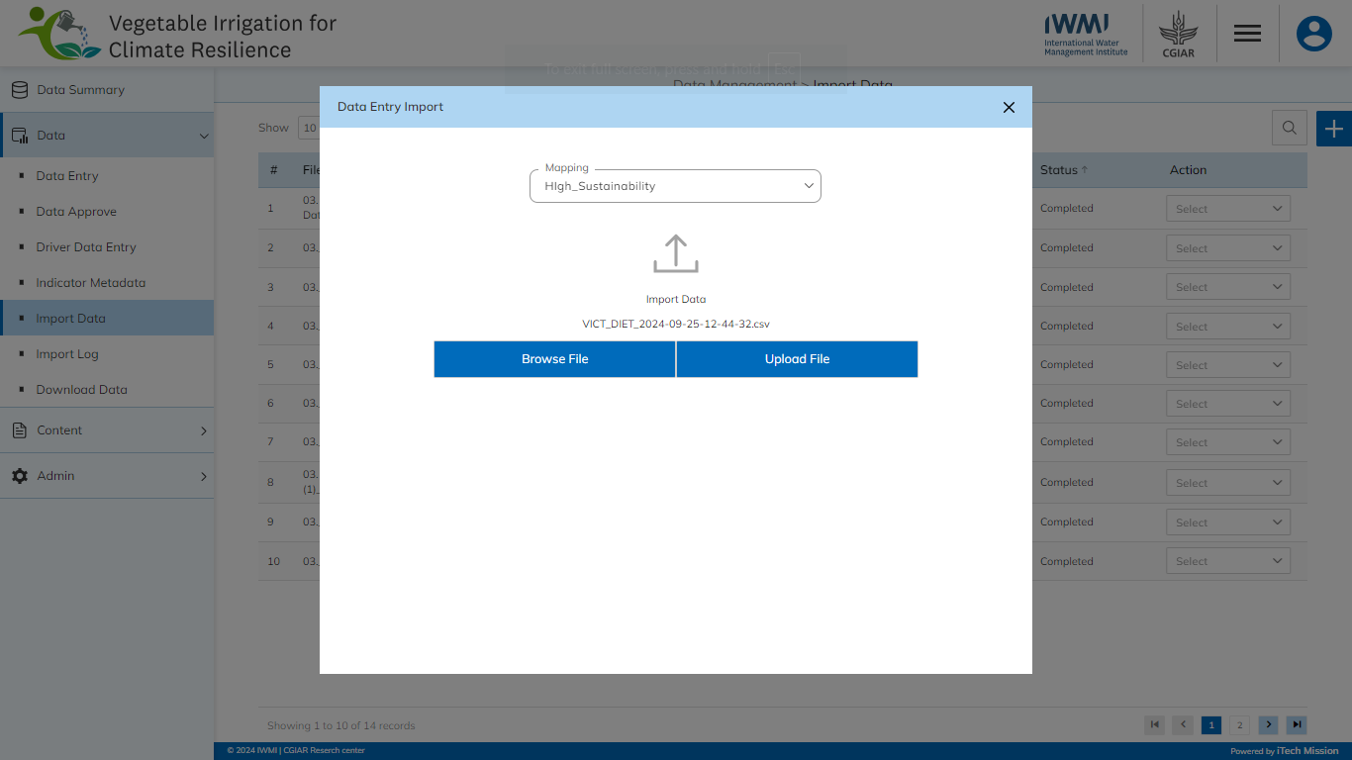Select the required module from the dropdown option available at the top left corner of the page. Click on the **Plus** button available at the top right corner to import the new bulk data file of the selected module. In the Data Entry Import popup window, select relevant mapping and then click on the **Browse File** button to select the data file. Now, click on the **Upload** button to start the import process (see below figure).

Click on the **Log Download** option available in the action dropdown to download the log file.

Click on the **Delete** option available in the action dropdown to delete the selected element. A confirmation popup will appear, click yes to confirm the deletion.

3.6 Import Log

Click the **Import** **Log** option in the left panel from the Data menu option to access this module. This module allows the management of the Import Log master list. You will have options to view the list of existing logs, download and view log reports, and delete selected logs (see below figure). 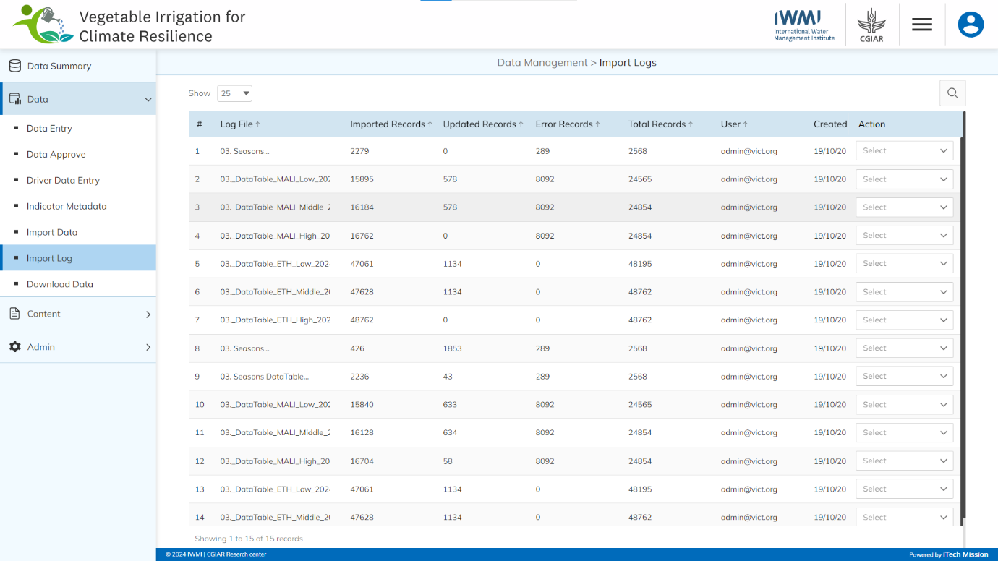

A log will be generated when any data template is imported into the database. A list of import logs is shown on this page where each import log is shown as a row. You can view the file name of each import log along with the log summary that includes: the count of records imported, count of records updated, count of error records, total records available in the import file, and date & time of the import. You also have the option to download the log file to view the reason for error records. The log file will be downloaded in CSV format.

Click on the **Download** option available in the action dropdown to download the log file.

Click on the **Delete** option available in the action dropdown to delete the selected element. A confirmation popup will appear, click yes to confirm the deletion.

* 1. DOWNLOAD DATA

Click the **Download Data** option in the left panel from the Data menu option to access this module. This module allows to download of master data available in the database. You will have options to view the list of modules, sort the list, search from the list, and download of the selected module in CSV formatted file (see below figure). 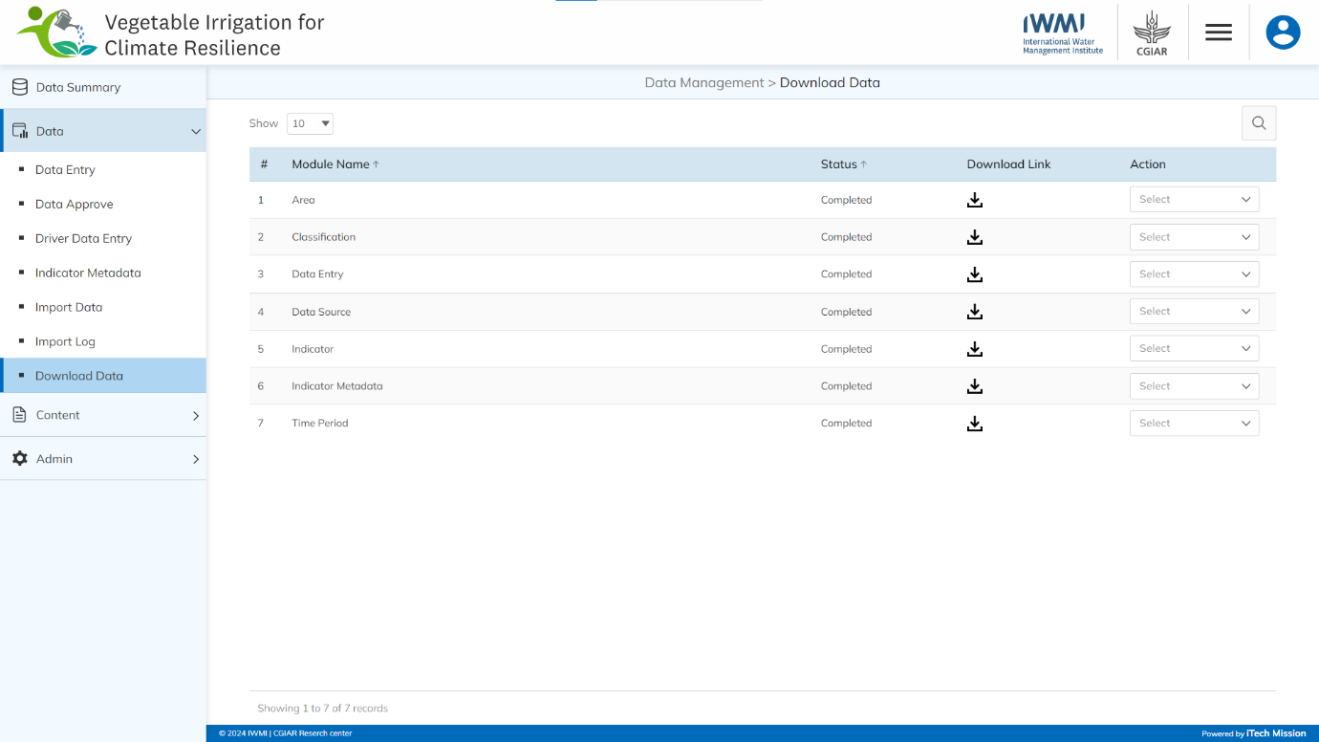

Click on the **Download Template** option available in the action dropdown to download the empty data template of the selected module in the CSV (Comma Separated Value) file format.

Click on the **Download Data** option available in the action dropdown to download the master data of the selected module in the CSV (Comma Separated Value) file format.

1. **CONTENT**

Click on the **Content** menu option from the left panel to access this module. This module has two submodules – Category-Subcategory and Documents. Let us understand these submodules in detail.

* 1. CATEGORY SUBCATEGORY

Click on the **Category Subcategory** from the Content menu option from the left panel to access this module. This module allows to manage the Category subcategory master list. You will have options to add a new element, view the list of existing elements, sort the list, search from the list, edit , and delete the existing elements (see below figure). 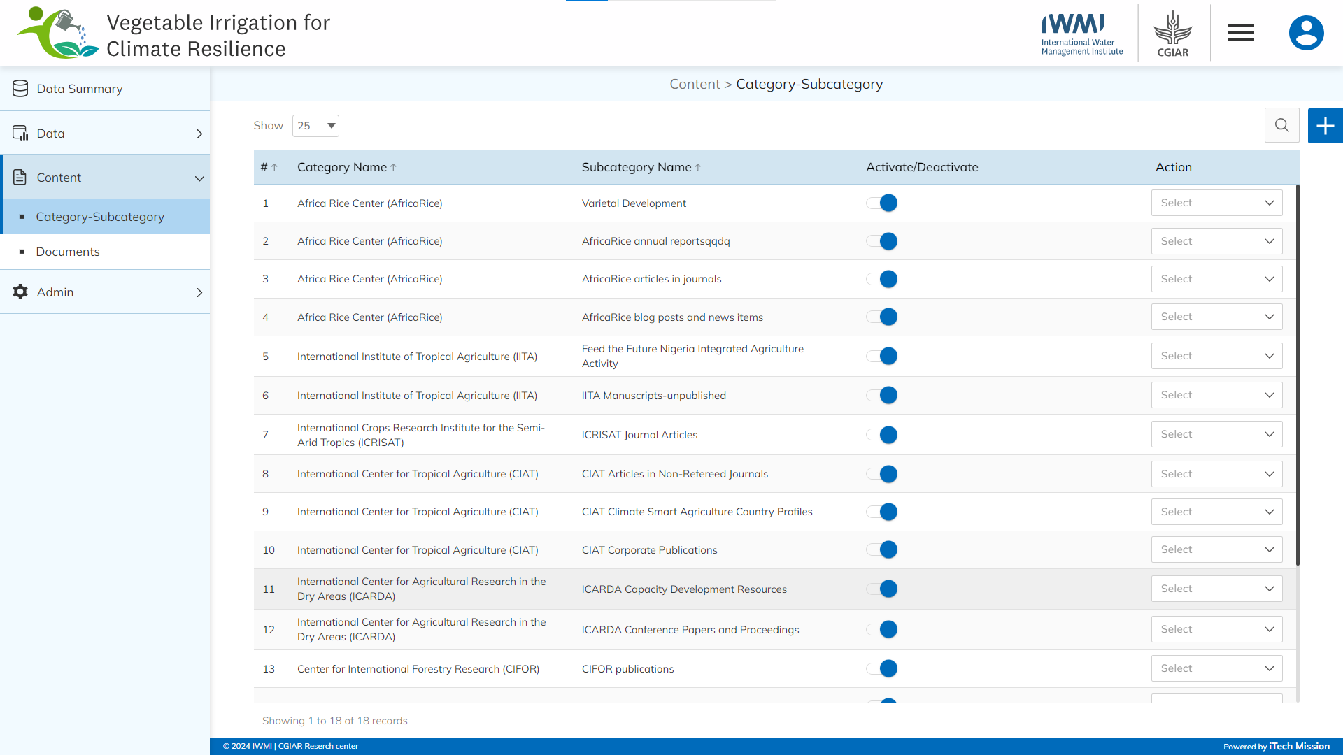

### Add

Click on the **Plus** button available at the top right corner to add a new indicator metadata record. Enter the following details to add a new record.

* Select **Category Name**
* Select **Subcategory Name**

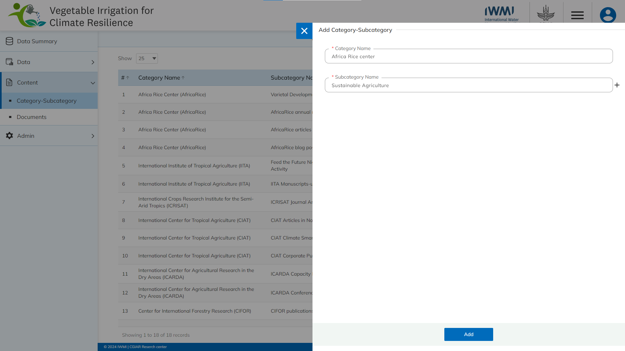All blue color details are mandatory to be entered. Click on the **Add** button to save and confirm. You can now view the new record added to the list.

Select the **Edit** option available in the action dropdown to edit the details of the selected element. Edit the required detail and click on the update button to save and confirm.

Select the **Activate/Deactivate** toggle button available to enable and disable the selected category-subcategory.

Selectthe **Delete** option available in the dropdown under the Action column to delete the selected element. A confirmation popup will appear, click yes to confirm the deletion.

* 1. DOCUMENTS

Click on the **Documents** from Content menu option from the left panel to access this module. This module allows you to manage the Documents master list. You will have options to add a new element, view the list of existing elements, sort the list, search from the list, edit , and delete the existing elements (see below figure). 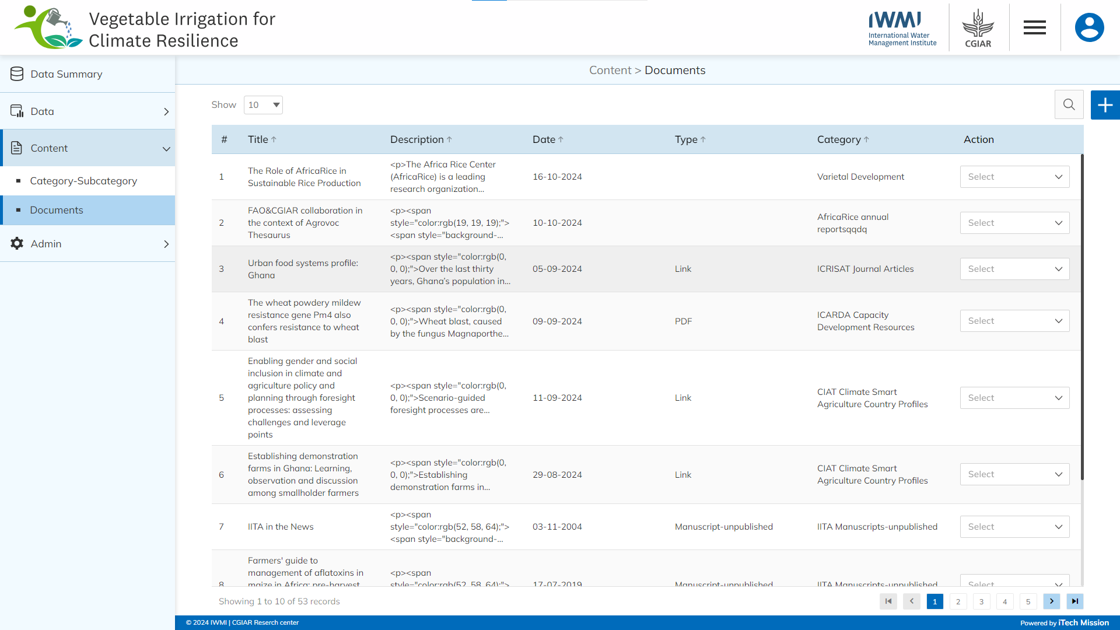

### Add

Click on the **Plus** button available at the top right corner to add a new document. Enter the following details to add a new document.

* Select **Group**
* Enter **Title**
* Enter **Description**
* Select **Document Date**
* Enter the **Video URL** (In case the selected group is Videos)
* Enter **Tags**
* Select **Categories/Subcategory**
* Enter **Document Type** (In case the selected group is Publications)
* Upload **Document** (In case the selected group is Publications)
* Upload **Image** (In case the selected group is Publications)

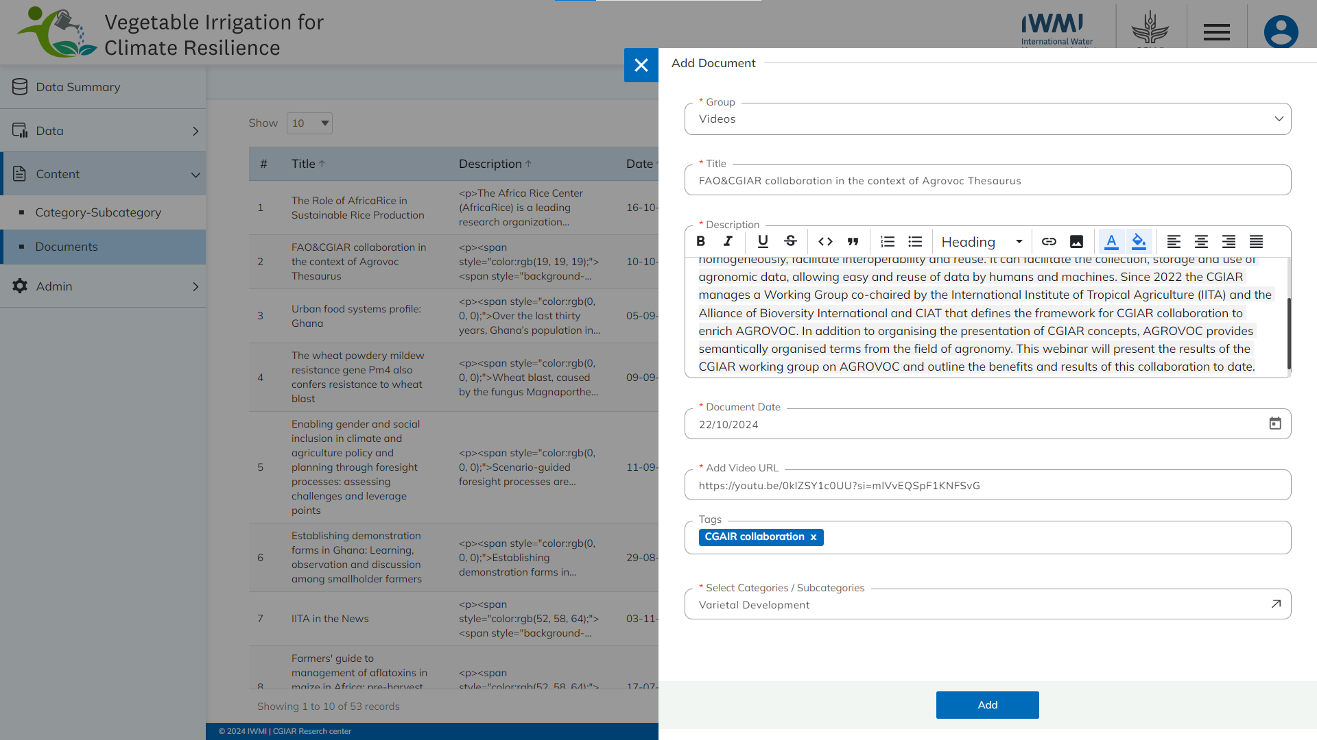All blue color details are mandatory to be entered. Click on the **Add** button to save and confirm. You can now view the new record added to the list.

Select the **Edit** option available in the action dropdown to edit the details of the selected element. Edit the required detail and click on the update button to save and confirm.

Selectthe **Delete** option available in the dropdown under the Action column to delete the selected element. A confirmation popup will appear, click yes to confirm the deletion.

1. **ADMIN**

Click on the **Admin** menu option from the left panel to access this module. This module has eight submodules – Area, Time Period, Data Source, Indicator, Import Mapping, Classification, User and Language. Let us understand these submodules in detail.

* 1. AREA

Click on the **Area** option from the admin menu option in the left panel to access this module. This module allows to manage the area master list. You will have options to export and import an area template, add a new area, view the list of existing areas, sort the list, search areas from the list, edit, and show/hide existing areas (see below figure). 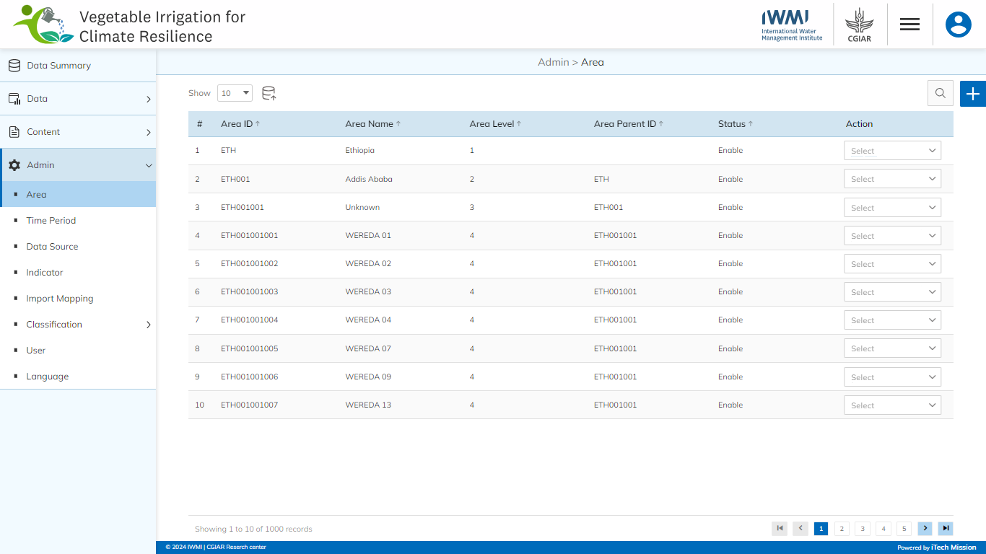

### Import

Click on the **Import** button to browse the file and upload the area master list into the database. To upload the area into the database, first enter the area structure in the template and then click on the **Browse File** button to select the template. Now, click on the Upload button to start the import process (see below figure).

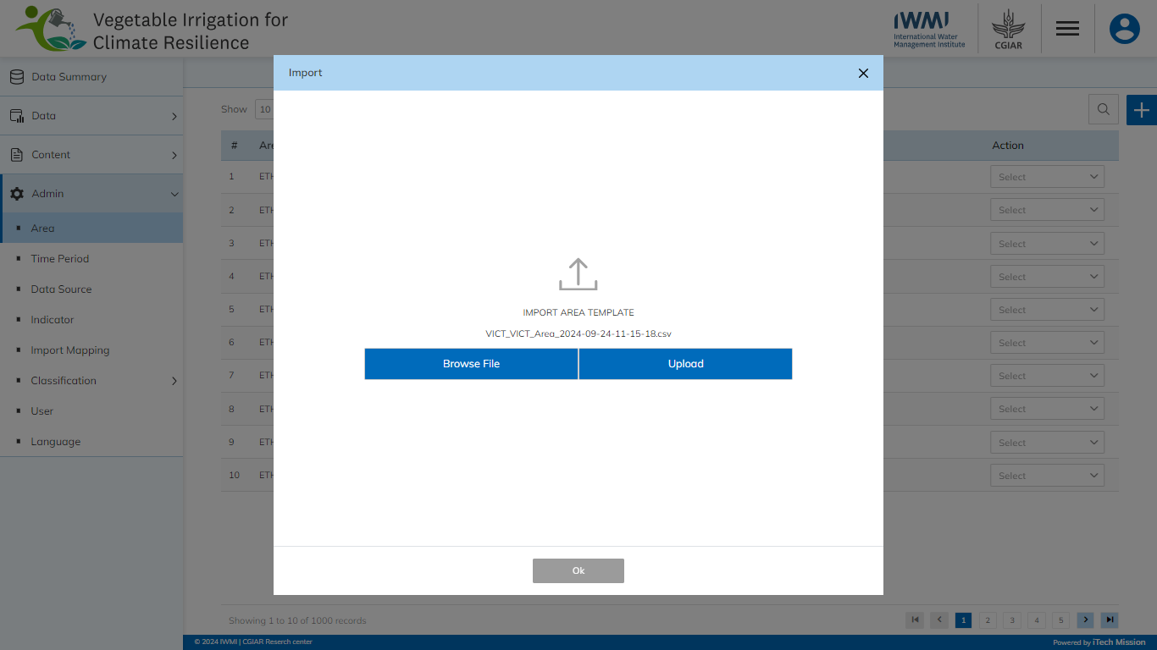During the import process, the records which contains blank entries, entries with special characters and duplicate entries are not imported in the database. A Last Upload summary will appear after the import process which provides the count of successfully imported records out of the total records. An error log will be generated to report on unsuccessful imported records which you can access from the Import Log module.

### Add

Click on the **Plus** button available on the right side of the page to add a new area. Enter the following details to add a new area.

* Enter **Name**
* Select **Parent Area** (In case child area is added)
* Enter **Area ID**

All blue color details are mandatory to be entered. Click on the **Add** button to save and confirm. You can now view the new area added to the area list.

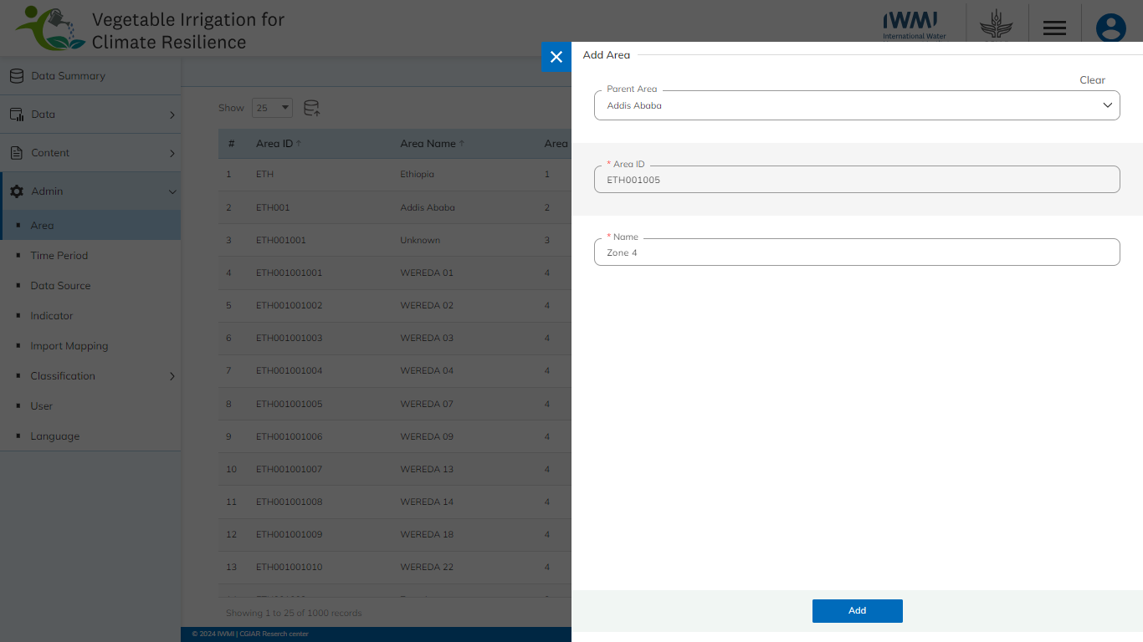Click on the **Edit** option available in the Action column to edit the details of the selected area. Edit the required detail and click on the update button to save and confirm.

Click to on the **Enable/Disable** option available in the action column to show or hide the specific area. The hidden area will not be shown in the list of areas throughout the application.

* 1. TIME PERIOD

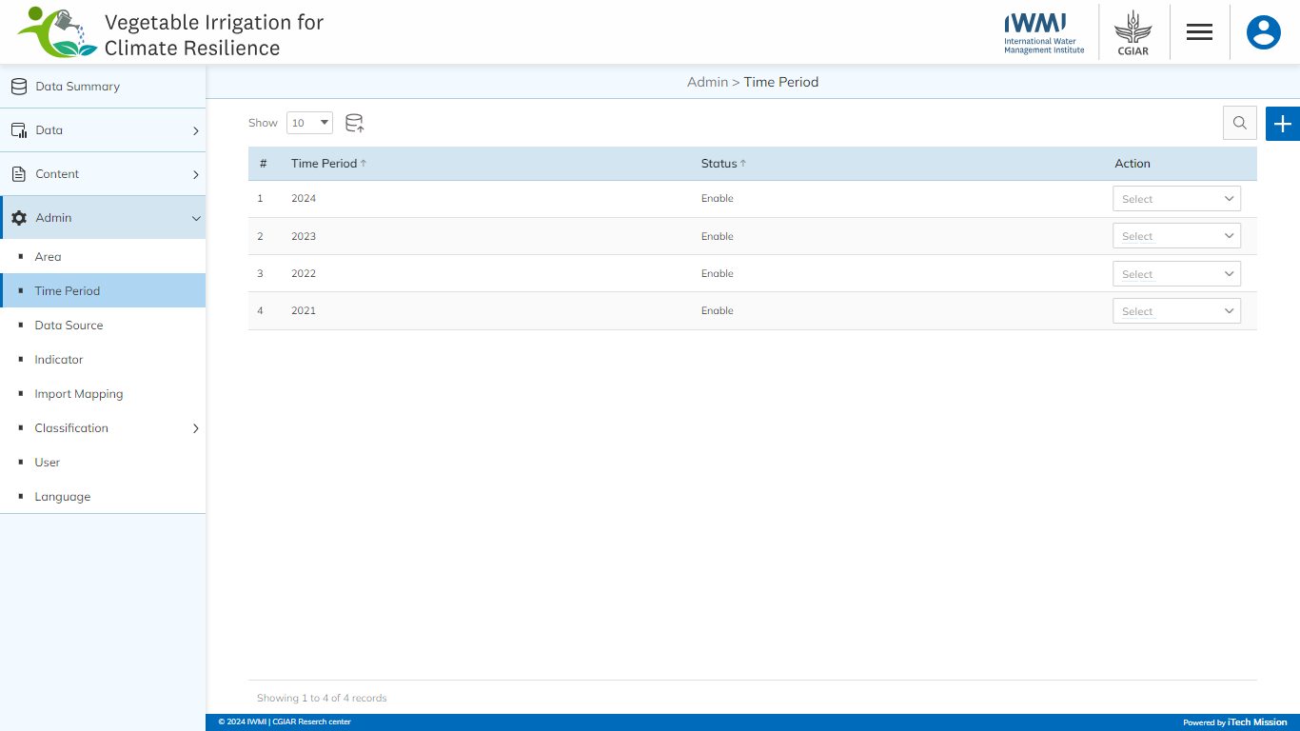Click on the **Time period** option from the admin menu option in the left panel to access this module. This module allows to manage the master list of time periods. You will have options to import or export time period templates, add a new Time period, view the list of existing Time period, sort the list, search Time period from the list, and edit an existing Time period.

Click on the **Plus** button available on the right side of the page to add a Time period. Enter the following details for the same.

* Enter Time Period

Click on the **Add** button to save and confirm. You can now view the new time period added to the list.

Click on the **Edit** option available in the action column to edit the selected time period and click on the **Update** button to save and confirm.

* 1. DATA SOURCE

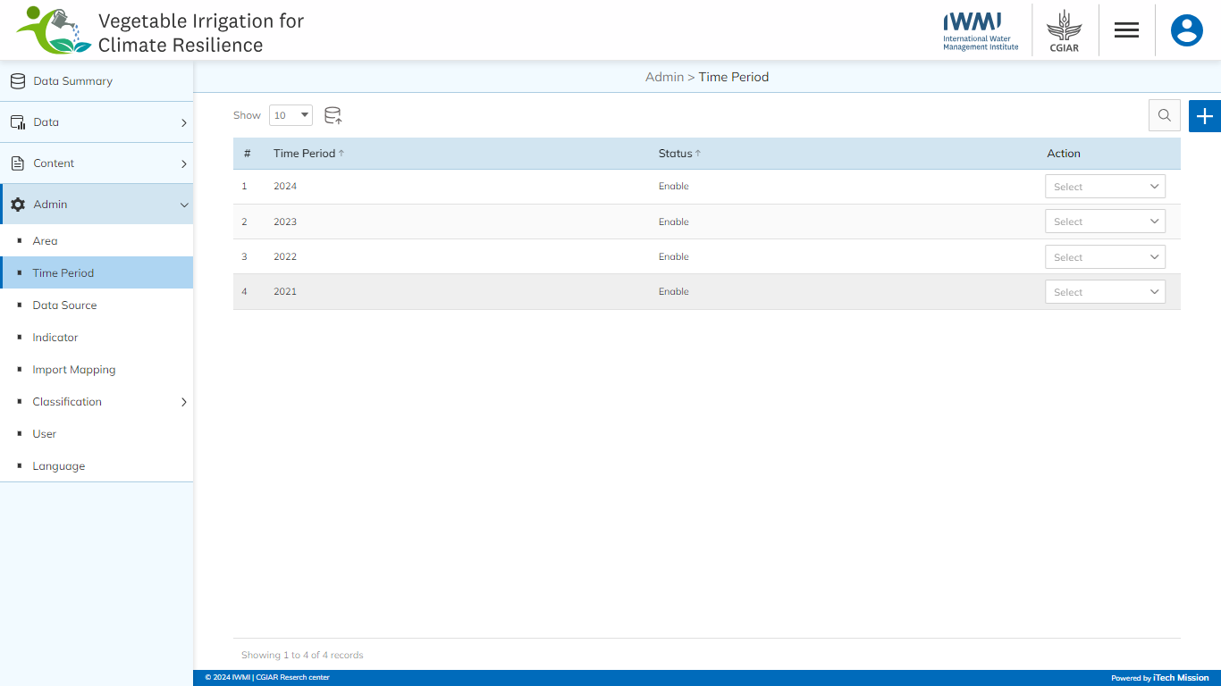Click on the **Data Source** option from the admin menu option in the left panel to access this module. This module allows to manage the master list of data sources. You will have options to import or export data source templates, add a new data source, view the list of existing data sources, sort the list, search data source from the list, and edit or delete an existing data source.

Click on the **Plus** button available to the right side of the page to add a Data source. Enter the following details for the same.

* Enter **Time Period**

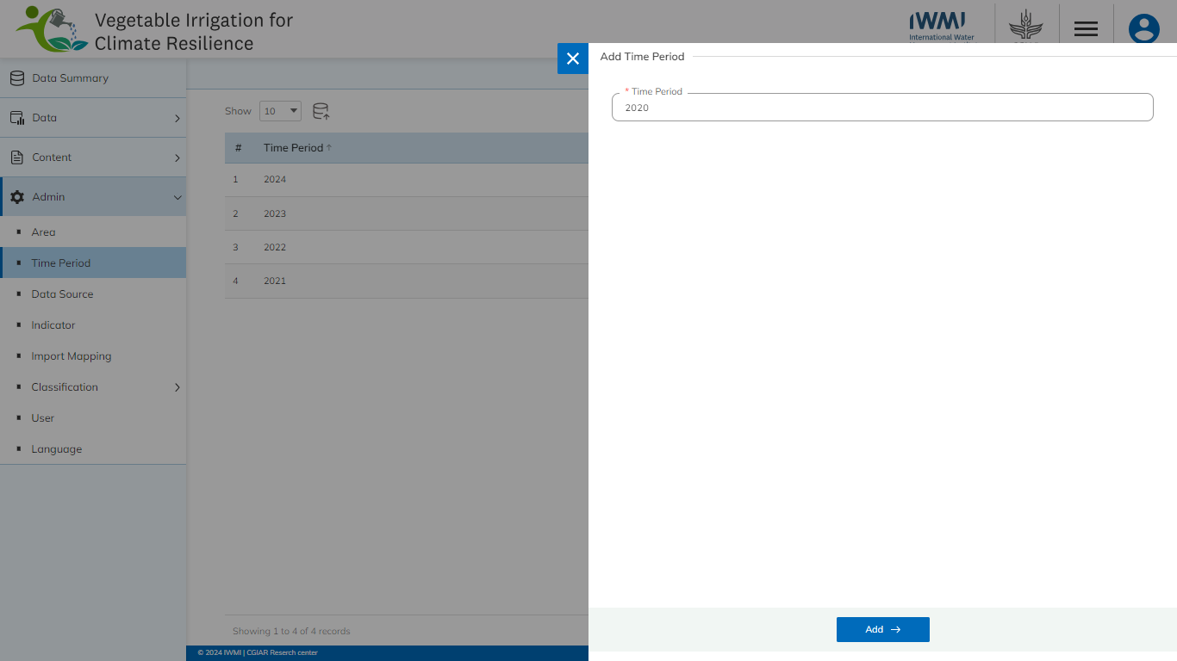Click on the **Add** button to save and confirm. You can now view the new data source added to the list.

Click on the **Edit** option available in the Action column to edit the selected data source and click on the **Update** button to save and confirm.

Click on the **Enable/Disable** option available in the action column to show or hide the specific data source. The hidden data source will not be shown in the list of data sources throughout the application.

* 1. INDICATOR

Click on the **Indicator** option from the admin menu option in the left panel to access this module. This module allows to manage the indicator master list. You will have options to export and import indicator templates, add new indicator-unit-subgroup (IUS) combinations, view the list of existing indicators, sort the list, edit, and Show/Hide existing Indicators (see figure below). 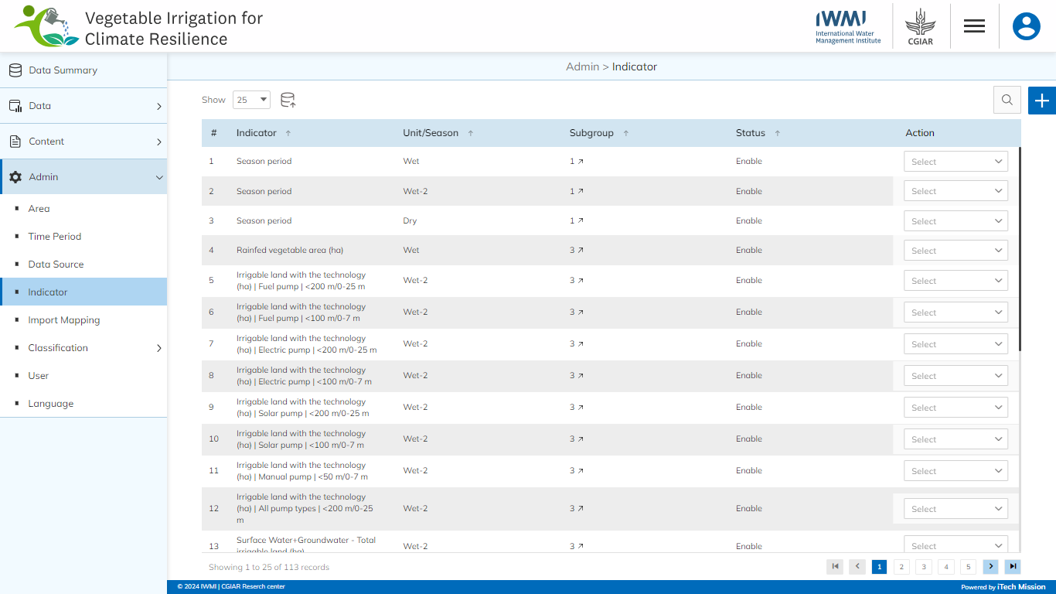

### Import

Click on the **Import** button to browse the file and upload the indicator master list into the database. To upload the indicator into the database first enter the indicator structure in the template as explained above and then click on the **Browse File** button to select the template. Now, click on the **Upload** button to start the import process.

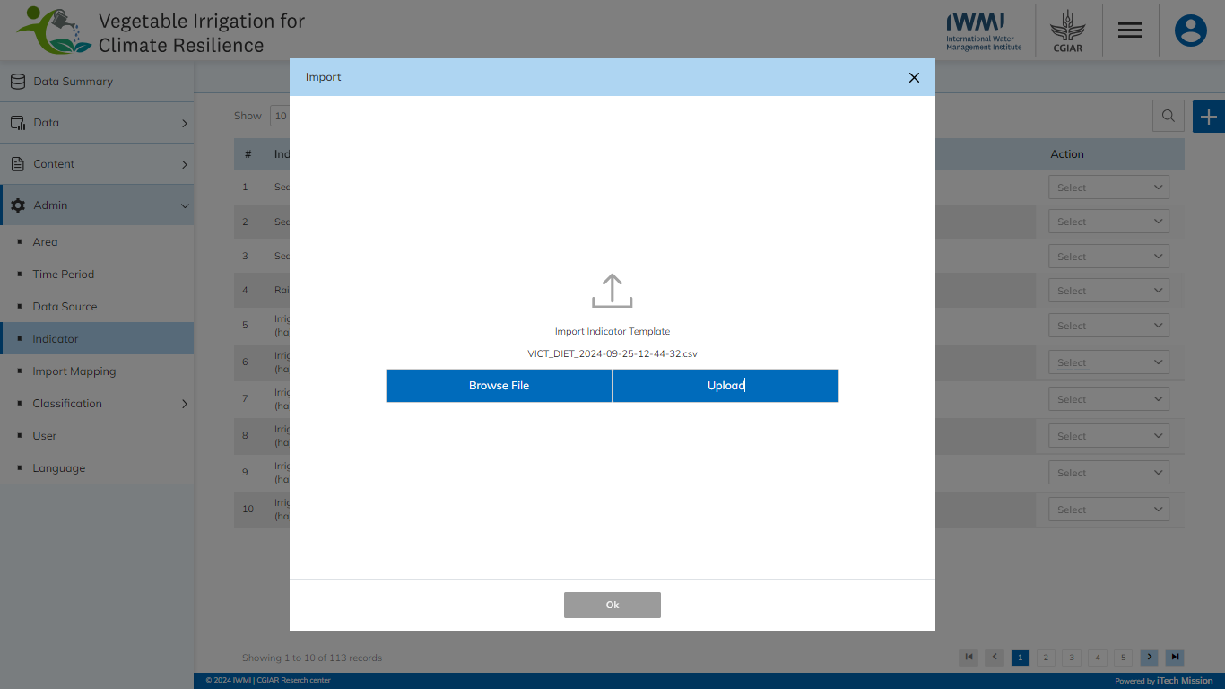During the import process, the records which contain blank entries, entries with special characters and duplicate entries are not imported into the database. A **Last Upload** summary will appear after the import process which provides the count of successfully imported records out of the total records. An error log will be generated to report on unsuccessful imported records which you can access from the **Import Log** module.

Each IUS should be classified under Sector - Subsector or Goal-Target. All other details are mandatory to be entered. Click on the **View** option available in the action column to view the details of the selected indicator.

* 1. IMPORT MAPPING

Click on the **Import Mapping** option from the admin menu option in the left panel to access this module. This module allows to manage the Import Mapping List. You will have options to add new mapping, view, sort, edit, and delete the existing mapping (see figure below) 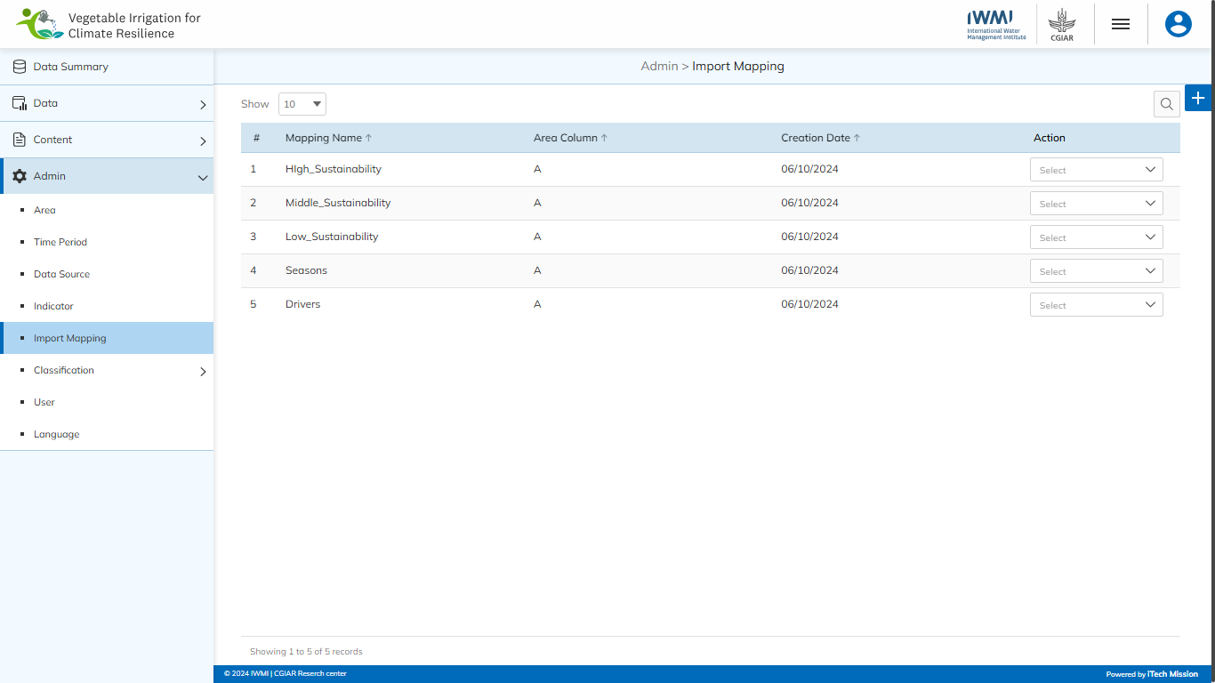

This submodule allows authorized users to create and manage the data mapping utility for adding and updating the data. Users can create the mapping files by specifying the correspondence between the target column and the mapped columns to import the respective data.

Below are the steps to create and manage the map file for CBRD enterprise registration data.

**Step 1:** Click on the **Plus** button available on the right side of the page to add a new import mapping (see figure below).

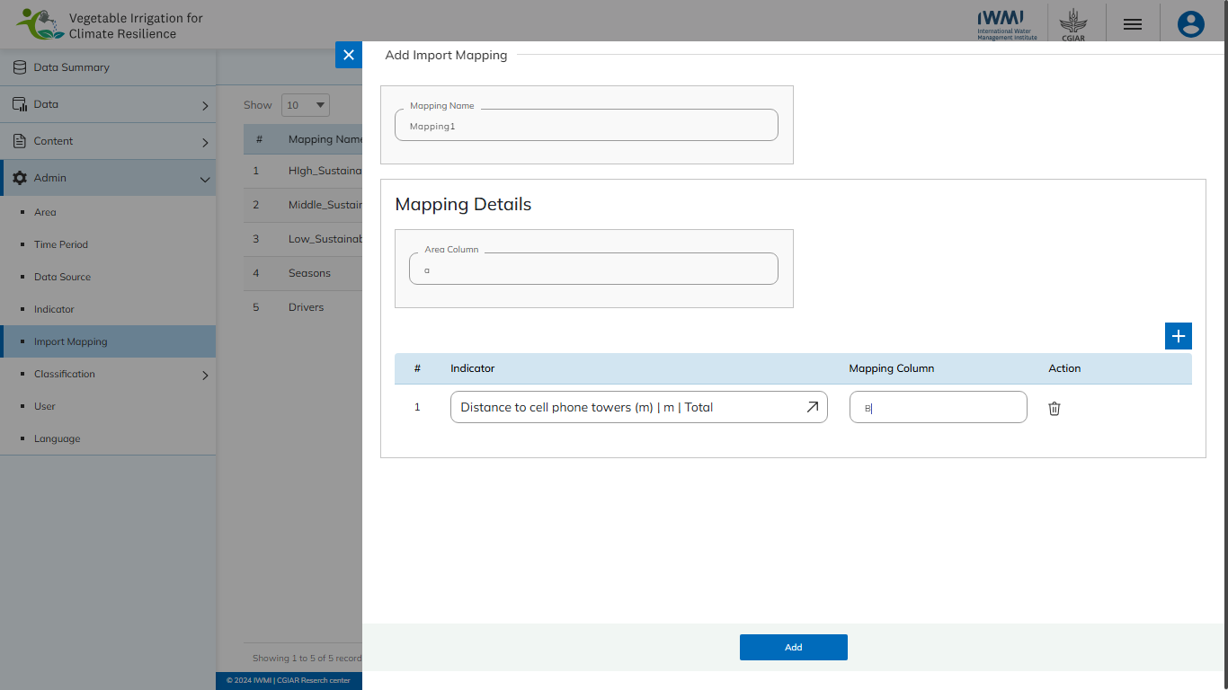 Enter the following details to add a new element.

* Enter the **Mapping Name**
* Enter the **Area Column**
* Select the **Indicator**
* Enter **Mapping Column**

**Step 2:** Click on the **Add** button.

Click on the **Plus** button available with the mapping column to add additional columns (if required).

Click on the **Edit** option available in the Action column to edit the details of the selected mapping. Edit the required detail and click on the **Update** button to save and confirm. Click on the **Delete** option available in the Action column to delete the selected mapping

* 1. CLASSIFICATION

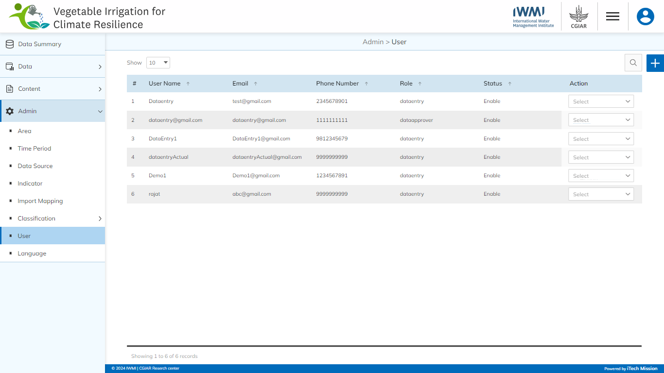Click on the **Classification Management** option from the admin menu option in the left panel to access this module. This module has two submodules – **Classification Type, and Classification** (see figure below).

Let us understand these submodules in detail.

### **6.6.1 CLASSIFICATION TYPE**

Click on **Classification Type** from the classification management menu option available in the left panel to access this module. This module allows the manage the classification type master list. You will have options to add a new classification type, view the list of existing classification types, sort the list, search from the list, edit, delete, and enable/disable existing classification types (see figure below). 

#### Add

Click on the **Plus** button available at the top right corner and enter the following information to add a new classification type.

* Enter **Classification Type**
* Select Global

All blue color details are mandatory to be entered. Click on the **Add** button to save and confirm. You can now view the new element added to the list.

Selectthe **Edit** option available in the action dropdown to edit the details of the selected element. Edit the required detail and click on the update button to save and confirm.

Select the **Enable/Disable** option available in the action dropdown to show or hide the specific classification type. The hidden type will not be shown in the overall application.

Selectthe **Delete** option available in the dropdown under the Action column to delete the selected element. A confirmation popup will appear, click yes to confirm the deletion.

### **6.6.2 Classification**

Click on **Classification** from the classification management menu option available in the left panel to access this module. This module allows the manage the classification master list. You will have options to export and import, add new classifications, view the list of existing classifications as per the type, sort the list, search from the list, edit, delete, and enable/disable existing classifications (see below figure) .

#### Import

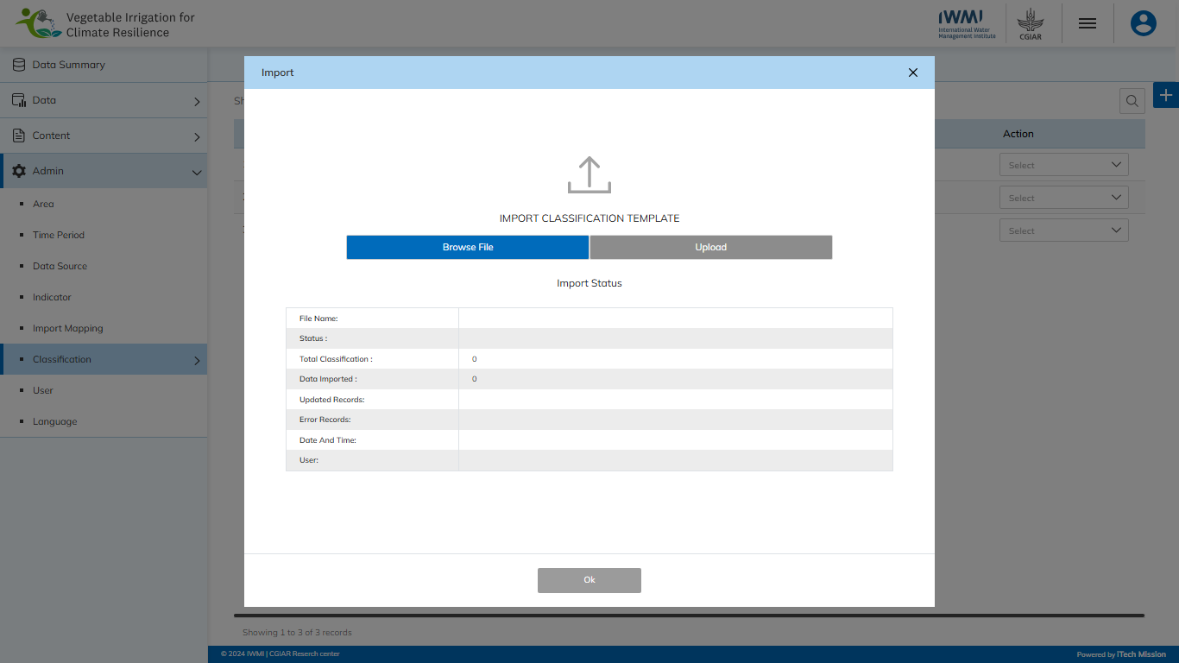Click on the **Import** button to browse the file and upload the area master list into the database. To upload the area into the database, first enter the area structure in the template and then click on the **Browse File** button to select the template. Now, click on the Upload button to start the import process (see below figure).

During the import process, the records which contain blank entries, entries with special characters and duplicate entries are not imported into the database. A Last Upload summary will appear after the import process which provides the count of successfully imported records out of the total records. An error log will be generated to report on unsuccessful imported records which you can access from the Import Log module.

#### Add

Click on the **Plus** button available on the right side of the page to add a new classification.

Enter the following details to add a new area.

* Select **Add or Import**
* Enter **Classification 1** *(If you want to enter more than 1 classification, click on Add New Classification***)**
* Check if **Global** 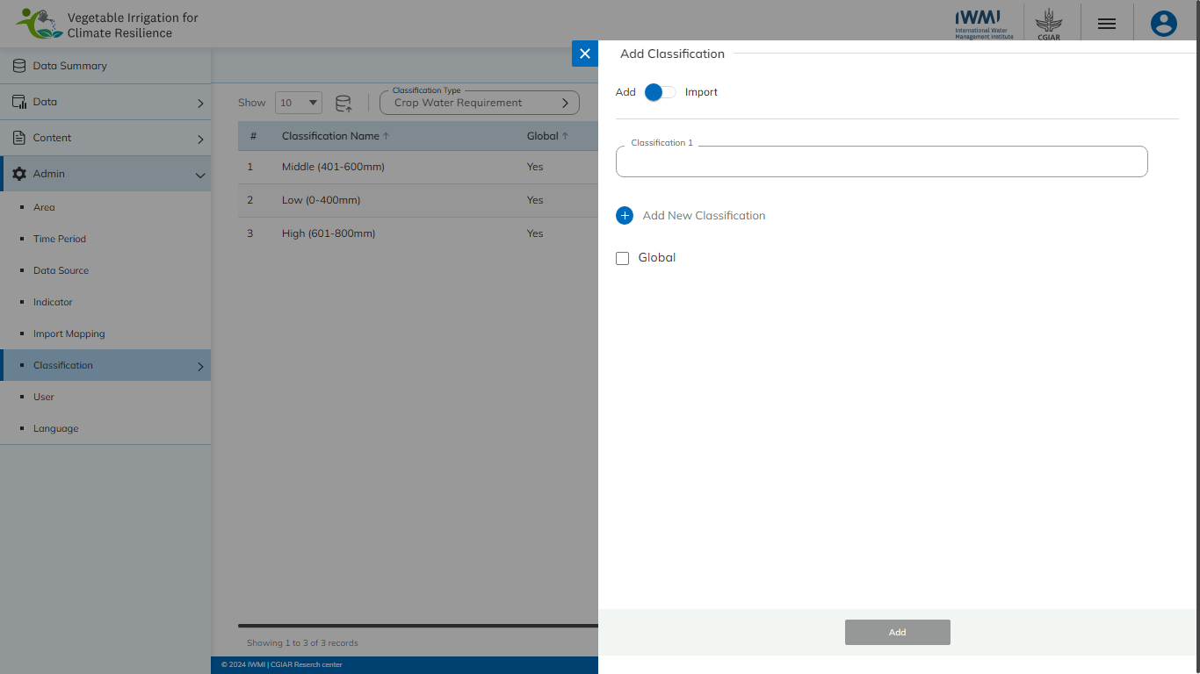

Click on the **Add** button to save and confirm. You can now view the new area added to the area list.

Click on the **Edit** option available in the Action column to edit the details of the selected area. Edit the required detail and click on the update button to save and confirm.

Click to on the **Enable/Disable** option available in the action column to show or hide the specific area. The hidden area will not be shown in the list of areas throughout the application.

* 1. USER

Click on the **User** option from the admin menu option in the left panel to access this module. This module allows to manage the User master list. You will have options to add new users, view the list of existing users, search users from the list, edit, and Show/Hide existing users (see figure below). 

Click on the **Plus** button available on the right side of the page to add a new user. Enter the following details to create a new user.

* Enter **User Name**
* Select **Area**
* Select Indicators(s)
* Enter **Email**
* Enter **Phone Number**
* Select **Role (Data Entry, Data Approver)**
* Set **Password**

All blue color details are mandatory to be entered. Click on the **Add** button to save and confirm. You can now view the new user added to the list.

Click on the **Edit** option available in the Action column to edit the details of the selected user. Edit the required detail and click on the **Update** button to save and confirm. Click on the **Enable/Disable** option available in the action column to active or inactive the selected user. The inactive user will not be able login into the application.

* 1. LANGUAGE

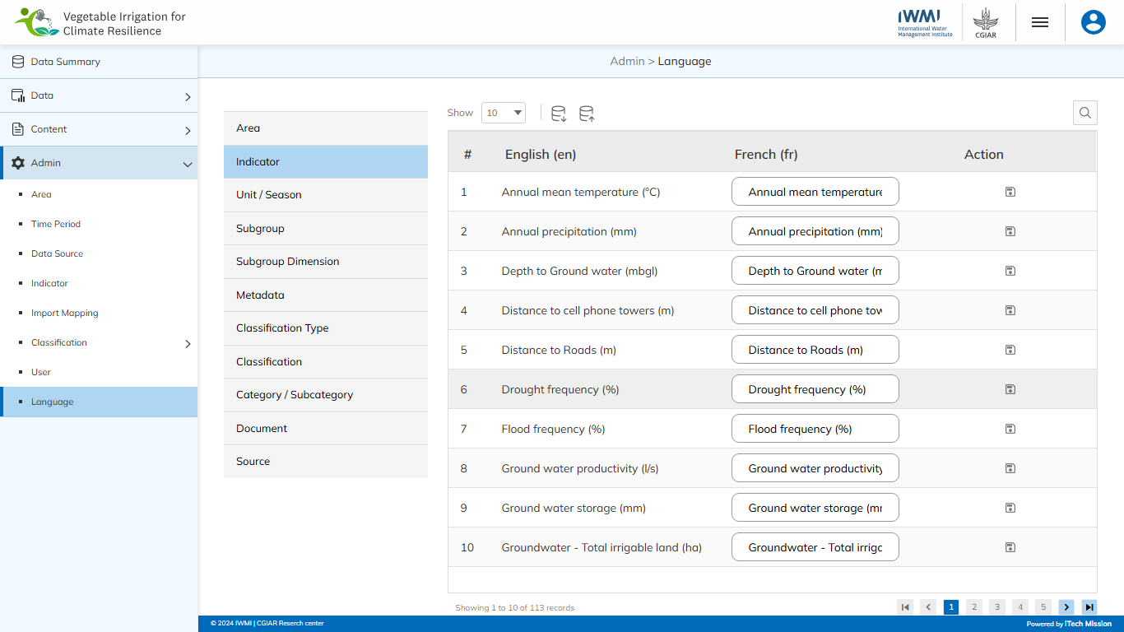Click on the **Language** option from the admin menu option in the left panel to access this module. This module allows to manage of the Language translations of each module. You will have options to import/export, view, search, edit, and save existing language (see figure below).

--- End of the document --